React List

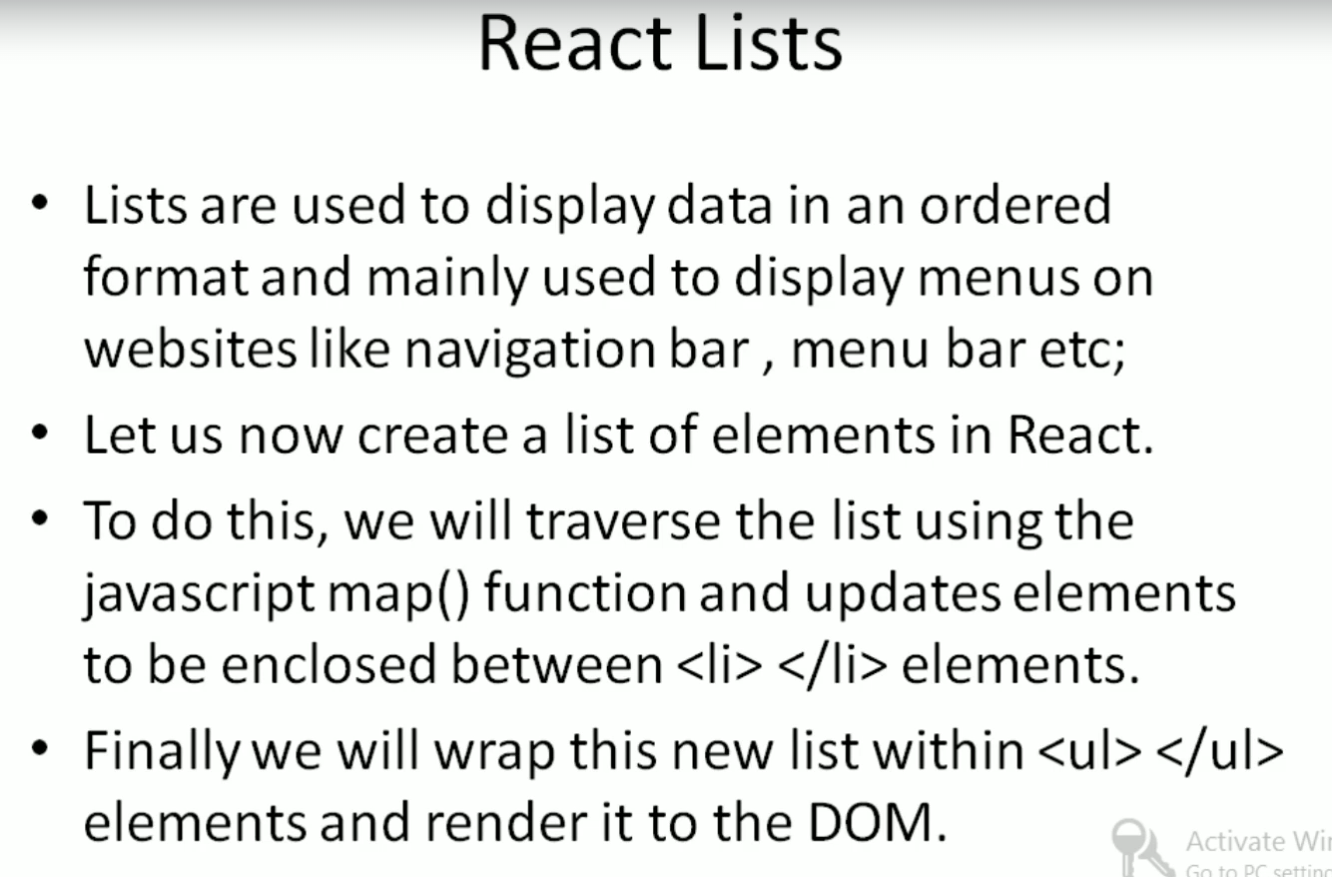

Create a newFile ListDemo.jsx

import React from "react";

const newlist=[1,2,3,4,5];

const r1 =newlist.map((litvaues) =>{

     return <li>{litvaues}</li>

 })

export default function CreateList()

{

    return <ul>{r1}</ul>

}

import logo from './logo.svg';

import './App.css';

import { Component } from 'react';

import CreateList from './Components/listDemo';

class App extends Component

{

  render(){

    const v={topic:"React Js",language:"Tamil",concept:'Props'};

    return (<div>

      <CreateList />

      </div>

      )

  }

}

export default App;

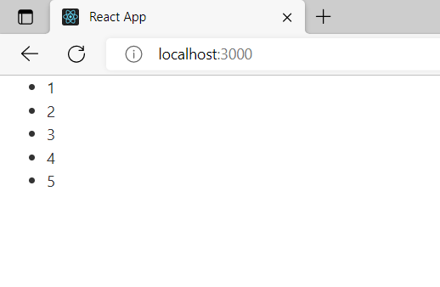

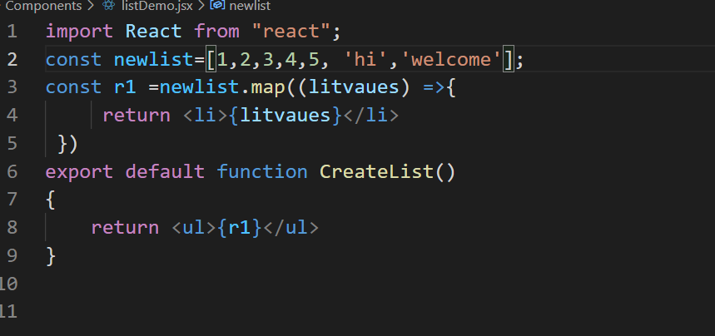

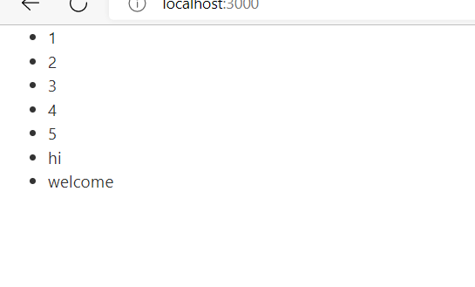

import React from "react";

const newlist=[1,2,3,4,5, 'hi','welcome'];

const r1 =newlist.map((listvaues ) =>{

     return <li>{listvaues + newlist}</li>

 })

export default function CreateList()

{

    return <ul>{r1}</ul>

}

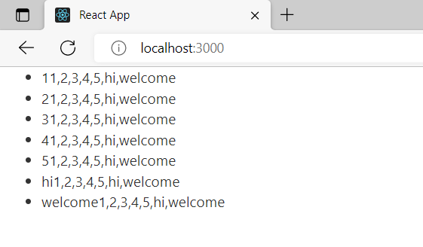

The same code we can write tin function component .In realtime everythin in any one of the component

import React from "react";

export default function CreateList()

{

    const newlist=[1,2,3,4,5, 'hi','welcome'];

const r1 =newlist.map((listvaues ) =>{

     return <li>{listvaues}</li>

 });

 return <ul>{r1}</ul>

}

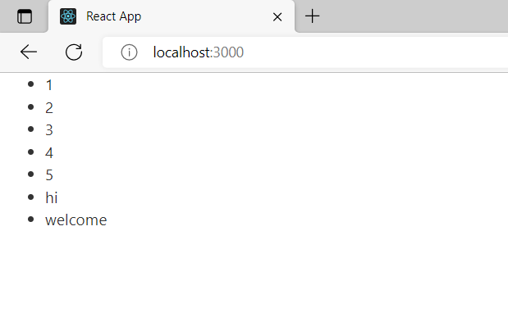

Listdemo.jsx

import React from "react";

export default function CreateList(props)

{

    const newlist=props.newlist;

const r1 =newlist.map((listvaues ) =>{

     return <li>{listvaues}</li>

 });

 return <ul>{r1}</ul>

}

App.jsx

import logo from './logo.svg';

import './App.css';

import { Component } from 'react';

import Mywebsite from './new/FunctionalComponent';

import Mynewwebsite from './new/ClassComponent';

import Mynewwebsite2 from './new/MainComponent';

import SingleProps from '../src/PropsDemos/SingleProps';

 import Learnreactpropschild from '../src/PropsDemos/ParentToChild';

 import Learnreactpropsparent from '../src/PropsDemos/ParentToChild';

import Reactstate from './StateDemos/State';

import CreateList from './Components/listDemo';

class App extends Component

{

  render(){

    const v={topic:"React Js",language:"Tamil",concept:'Props'};

    const myvalues=[10,20,30,40,50,60,70];

    return (<div>

      <CreateList newlist={myvalues}/>

      </div>

      )

  }

}

export default App;

